Part B
- Ted
- Figure or Diagram:
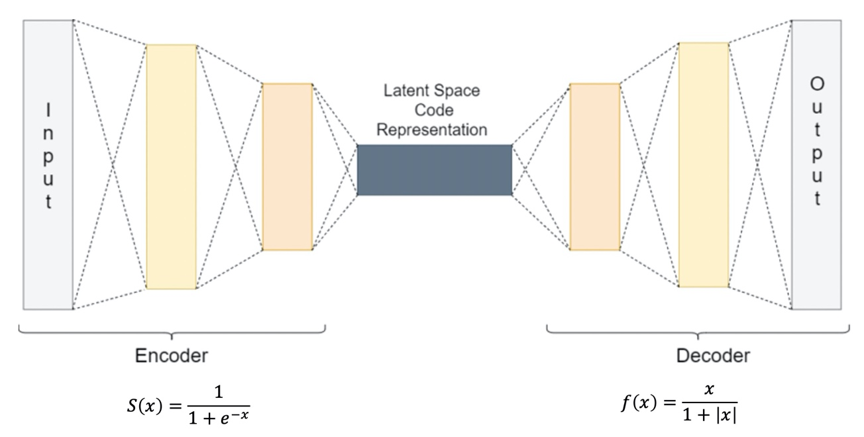
Here we use the figure to help us explain what happened in the Autoencoder. The idea is quite straight forward. We write our own activation function and keep on testing for different layers and where to put our $f(x)$. After we find the best position to put it, which is in the decoder, we tune for the hyperparameters like part A.

- Comparison or Demonstration:
After testing 20~30 different setup with $f(x)$, we found the best setup is the original setup with S(x) first then $f(x)$ in the forward function. Here is the comparison of our model from part A and part B.
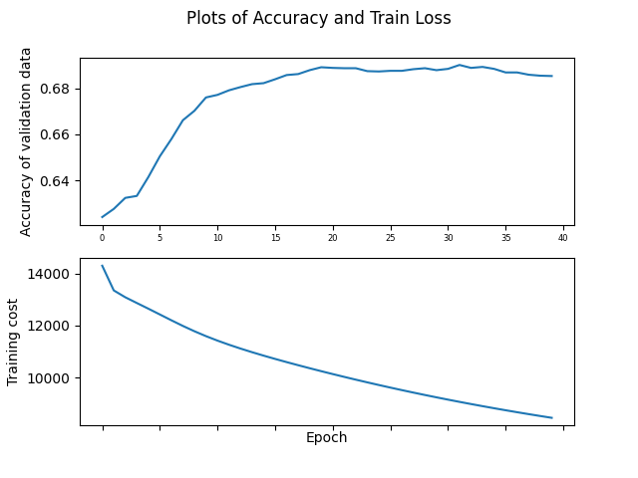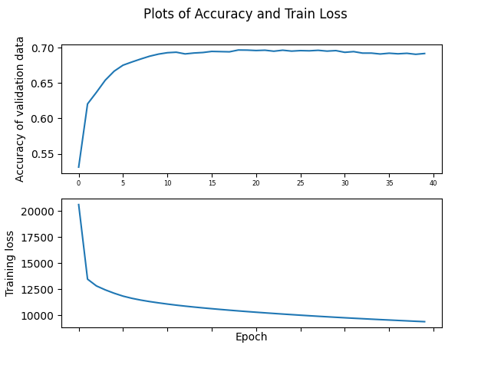
The left figure shows our neural network from part A and the right figure is from part B. The comparison is straight forward. The speed for the model to reach maximum accuracy and the maximum accuracy itself are higher than part A. For our part B, we’ve reached a training accuracy of 0.696725938470223 and a testing accuracy of 0.6996895286480384 as the figure shown. Further more, the model is more stable. Both figure shows the model without regularization and our model from part B is much more tenable to the overfitting property of neural network.

- Limitation: changing the order of $f(x)$ or adding layers will not increase. Besides that, the training cost is almost doubled.

For the first limitation, the function we found must be placed in a specific order. One possible explanation is the shape of data, after encoded by the sigmoid activation function, is more suitable for $f\left(x\right)$ to decode. There might be other deeper reason behind this. Our guess is the shape of sigmoid is similar with $f\left(x\right)$
$$S\left(x\right)=\frac{1}{1+e^{-x}}=\frac{e^{x}}{1+e^{x}}, f\left(x\right)=\frac{x}{1+\left|x\right|}$$

For the second limitation, it’s easy to explain. Because we are creating activation functions by using some build-in functions of torch, the training cost must increase. It’s an unavoidable disadvantage of our approach. Luckily the training cost drops down to normal training cost from the second epoch.

